**DAY – 3  
 (Deployment of kubernetes)**

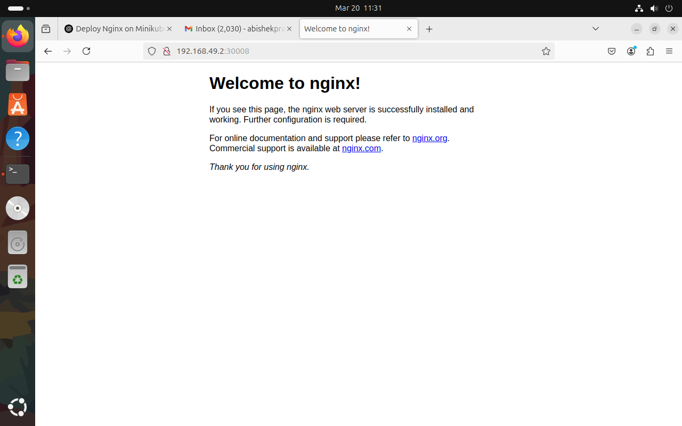

**abishekpranav@abishekpranav-VMware-Virtual-Platform:~$ minikube start**  
  minikube v1.35.0 on Ubuntu 24.04  
  Using the docker driver based on existing profile  
  Starting "minikube" primary control-plane node in "minikube" cluster  
  Pulling base image v0.0.46 ...  
  Restarting existing docker container for "minikube" ...  
  Preparing Kubernetes v1.32.0 on Docker 27.4.1 ...  
  Verifying Kubernetes components...  
     Using image [gcr.io/k8s-minikube/storage-provisioner:v5](http://gcr.io/k8s-minikube/storage-provisioner:v5)  
  Enabled addons: storage-provisioner, default-storageclass  
  Done! kubectl is now configured to use "minikube" cluster and "default" namespace by default

**abishekpranav@abishekpranav-VMware-Virtual-Platform:~$ kubectl apply -f nginx-deployment.yml**

deployment.apps/nginx-login created  
error: error parsing nginx-deployment.yml: error converting YAML to JSON: yaml: line 7: mapping values are not allowed in this context

**abishekpranav@abishekpranav-VMware-Virtual-Platform:~$ kubectl apply -f nginx-deployment.yml**

deployment.apps/nginx-login unchanged  
service/nginx-login-service created

**abishekpranav@abishekpranav-VMware-Virtual-Platform:~$ kubectl delete -f nginx-deployment.yml**

deployment.apps "nginx-login" deleted  
service "nginx-login-service" deleted

**abishekpranav@abishekpranav-VMware-Virtual-Platform:~$ kubectl apply -f nginx-deployment.yml**  
deployment.apps/nginx-login created  
service/nginx-login-service created

**abishekpranav@abishekpranav-VMware-Virtual-Platform:~$ kubectl get pods**  
**kubectl get deployments  
kubectl get services**

NAME                          READY   STATUS    RESTARTS   AGE  
nginx-login-b6fd8c4cf-zj8sj   1/1     Running   0          9s  
NAME          READY   UP-TO-DATE   AVAILABLE   AGE  
nginx-login   1/1     1            1           9s  
NAME                  TYPE        CLUSTER-IP     EXTERNAL-IP   PORT(S)        AGE  
kubernetes            ClusterIP   10.96.0.1      <none>        443/TCP        41h  
nginx-login-service   NodePort    10.106.75.42   <none>        80:30008/TCP   9s  
abishekpranav@abishekpranav-VMware-Virtual-Platform:~$ minikube service nginx-login-service --url  
[http://192.168.49.2:30008](http://192.168.49.2:30008/)